

**Pyanshu Shaw**

**pyanshu2001@gmail.com**

Abstract

The System greatly lowers manual efforts and allows for a seamless flow of hospital activities by eliminating the possibility of errors when doing its activities.

Project By – Mr. Pyanshu Shaw

HOSPITAL

MANAGEMENT

SYSTEM

**HOSPITALITY MANAGEMENT SYSTEM**

**Description:**

Hospitals are the most important part of our lives, trying to provide the best medical facilities to people suffering from various type of illness, which may be due to change in climate conditions, increased work-load, emotional trauma stress etc. It is very much difficult for the hospital to maintain its day-to-day activities and records manually. That is why a database is required to keep records of all type of activities of a hospital.

Hospitals interact with a lot of people in a day and there are various activities involved in day-to-day operations of hospitals, for example managing doctor schedules, managing patient diagnoses, managing medical histories of patients, etc. The aim of this project is to show how data related to these tasks can be made easier to manage using databases.

By storing information in a relational database, all the tasks relate to daily functioning of the hospital can be performed easily and much more efficiently. Hospital Database Management System (DBMS) is a comprehensive SQL project designed to streamline and optimize the management of hospital operations. This project aims to provide an efficient and user-friendly solution for storing, retrieving, and manipulating various types of healthcare-related data.

**HOSPITALITY MANAGEMENT SYSTEM**

**1) Problem Statement:** Managing hospitality services, including room bookings, patients’ management, room allocations, and payments, often involves handling large volumes of data. Many small to medium-sized hospitals struggle with manual data management, leading to errors, double bookings, and poor patients’ service. This project aims to streamline operations by implementing an SQL-based system to manage all aspects of hospitality services efficiently.

**2) Objective:** The objective of this project is to design and develop an SQL-based Hospitality Management System that simplifies booking, room allocation, billing, and patients’ relationship management. The system will ensure data consistency, reduce human errors, and provide quick access to critical information for better decision-making.

**3) Technology Used in the Project:**

* SQL (Structured Query Language) for database management
* MySQL as the database management system

**4) Scope of the Project and Project Concept in Diagram:**

* The project will cover patients’ registration, room bookings, payments, treatment details, prescription history, staff management, doctors’ specialty and one-on-one interaction with patients’ and feedback systems.
* **Concept Diagram:**

DEPARTMENT

APPOINTMENT

ROOM

PHARMACY

DOCTOR-PATIENT

PAYMENT

PATIENT

TREATMENT

TREATMENT DETAILS

FEEDBACK

PRESCIPTION

PRESCRIPTION HISTORY

SPECIALITY

NURSE

NURSE WARD

DOCTOR SPECIALITY

DOCTOR

**5) Components of the Project:**

1. **Patient Management**: Registering, updating, and managing Patient details.
2. **Room Management**: Handling room details, availability, and pricing.
3. **Booking System**: Facilitating room reservations and cancellations.
4. **Billing System**: Generating invoices and handling payments.
5. **Doctor Management**: Managing staff details and assignments.
6. **Feedback System**: Collecting and analyzing customer feedback.

ER DIAGRAM

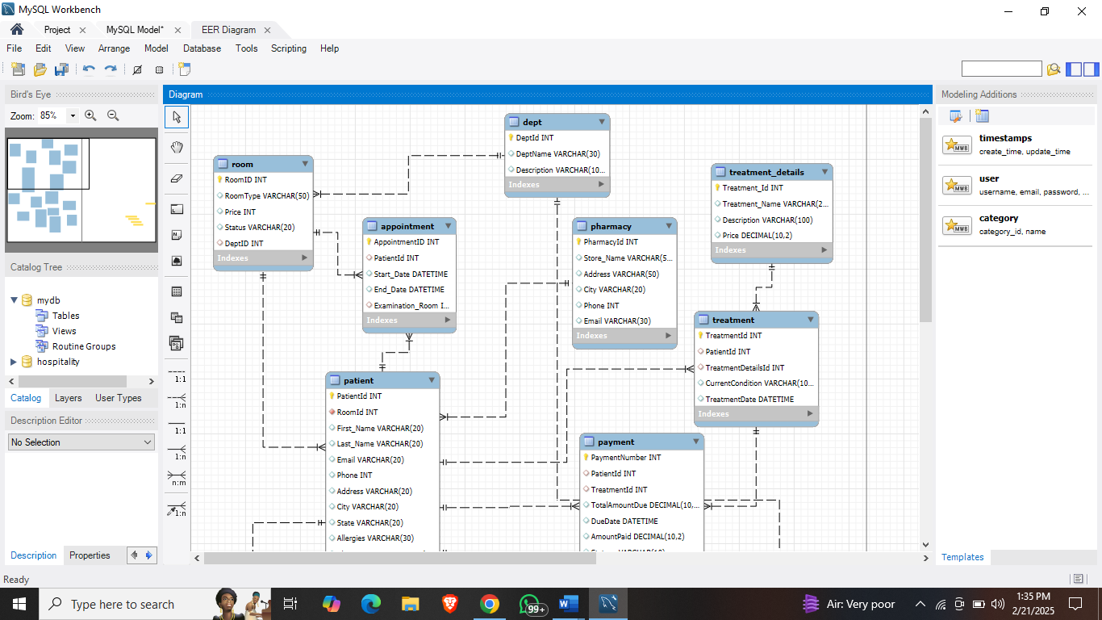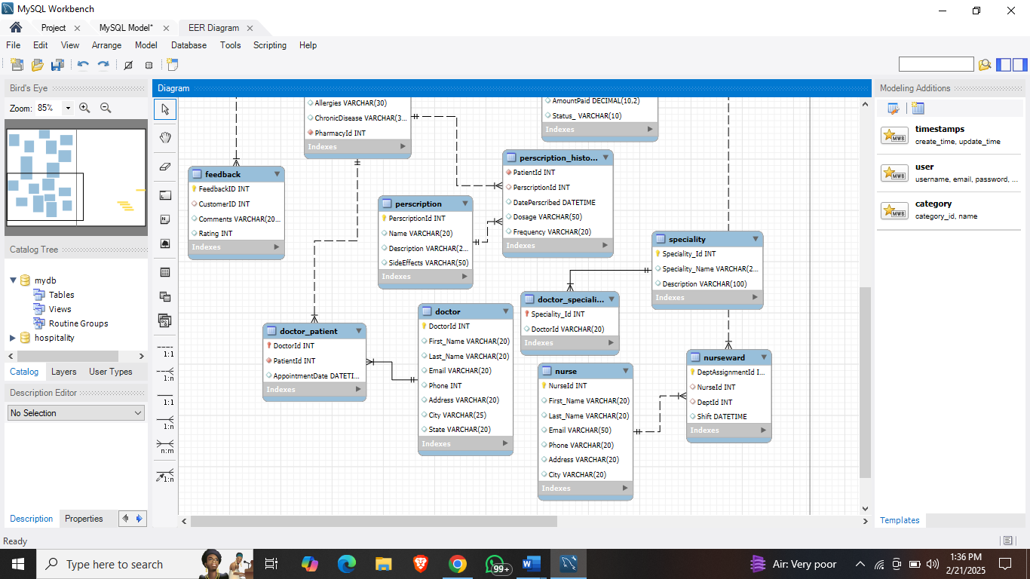

**6) Tables included in the Project:**

**1. Department:**

* **DeptID:** this is a unique ID for a department
* **DeptName:** this is the name of a department
* **Description:** this is the description of each department.

**2. Room:**

* **RoomID:** this is a unique ID for a Room
* **DeptID:** this is the ID of the Department which is referencing to the column DeptID of the Department table
* **RoomType:** this is the various types of rooms available in hospital
* **Price:** this is the price of each type of rooms
* **Status:** this is the status of rooms like is it available or vacant.

**3. Pharmacy:**

* **PharmacyId:** this is the unique ID of Pharmacy
* **Store_Name:** this is the store name of pharmacies
* **Address:** this is the address of every pharmacy store
* **City:** this is the city where the pharmacy store is situated
* **Phone:** this is the phone number of each pharma store.

**4. Patient:**

* **PatientId:** this is the unique ID of Patients
* **RoomId:** this is the ID of the Room which is referencing to the column RoomID of the Room table
* **First_Name:** this is the first name of patients
* **Last_Name:** this is the last name of patients
* **Email**: this is the email of the patients
* **Phone:** this is the phone number of patients
* **Address:** this is the address of patients
* **City:** this is the city of patients
* **State:** this is the state of patients
* **Allergies:** this is the allergies of patients
* **ChronicDisease:** this is the disease of patient with respect to allergies
* **PharmacyId:** this is the ID of the Pharma which is referencing to the column PharmacyID of the Pharmacy table.

**5. Feedback:**

* **FeedbackID:** this is the unique ID of feedback
* **CustomerID:** this is the ID of the Customer which is referencing to the column PatientID of the Patient table.
* **Comments:** this is the comment section for the patients
* **Rating:** this is the rating where patient has rated as their service

**6. Treatment_Details:**

* **Treatment_Id:** this is the unique ID of treatment_details
* **Treatment_Name:** this is the name of all the treatment available
* **Description:** this is the description of all treatment provided
* **Price:** this is the price of the particular treatment provided

**7. Treatment:**

* **TreatmentID:** this is the unique ID of treatment
* **PatientId:** this is the ID of the Patient which is referencing to the column PatientID of the Patient table.
* **TreatmentDetailsId:** this is the ID of the TreatmentDetails which is referencing to the column TreatmentID of the Treatment_Details table.
* **CurrentCondition:** this is the current condition of each patient
* **TreatmentDate:** this is the date of treatment of the patient

**8. Payment:**

* **PaymentNumber:** this is the unique ID of Payment
* **PatientId:** this is the ID of the Patient which is referencing to the column PatientID of the Patient table.
* **TreatmentId:** this is the ID of the Treatment which is referencing to the column TreatmentID of the Treatment table.
* **TotalAmountDue:** this is the amount due of each patient
* **DueDate:** this is the due date of patients
* **AmountPaid:** this is the amount cleared by the patients

**9. Prescription:**

* **PerscriptionId:** this is the unique ID of Prescription
* **Name:** this is the name of prescriptions
* **Description:** this is the description of the prescription
* **Side Effects:** this is the side-effects which patients will observe

**10. Perscription_History:**

* **PatientId:** this is the ID of the Patient which is referencing to the column PatientID of the Patient table.
* **PerscriptionId:** this is the ID of the Prescription which is referencing to the column PrescriptionID of the prescription table.
* **DatePerscribed:** this is the date for taking the prescription
* **Dosage:** this is the dosage which patients have to take
* **Frequency:** this is the frequency of dosage

**11. Doctor:**

* **DoctorId:** this is the unique ID of Doctor
* **First_Name:** this is the first name of the doctor
* **Last_Name:** this is the last name of the doctor
* **Email:** this is the email of the doctor
* **Phone:** this is the contact info of the doctor
* **Address:** this is the location of the doctor
* **City:** this is the city where the doctor belongs to
* **State:** this is the state of the doctor’s resident

**12. Appointment:**

* **AppointmentID:** this is the unique ID of Appointment
* **PatientId:** this is the ID of the Patient which is referencing to the column PatientID of the Patient table.
* **Start_Date:** this is the starting of the appointment
* **End_Date:** this is the ending of the appointment
* **Examination_Room:** this is the ID of the room which is referencing to the column RoomID of the Room table.

**13. Nurse:**

* **NurseId:** this is the unique ID of Appointment
* **First_Name:** this is the first name of the Nurse
* **Last_Name:** this is the last name of the Nurse
* **Email:** this is the email of the Nurse
* **Phone:** this is the contact info of the Nurse
* **Address:** this is the location of the Nurse
* **City:** this is the city where the Nurse belongs to

**14. NurseWard:**

* **DeptAssignmentId:** this is the unique ID of Ward
* **NurseId:** this is the ID of the Nurse which is referencing to the column nurseID of the Nurse table
* **DeptId:** this is the ID of the Department which is referencing to the column DeptID of the Dept table
* **Shift:** this is the shift timing of nurses

**15. Specialty:**

* **Speciality_Id:** this is the unique ID of Specialty
* **Speciality_Name:** this is the name of several specialties
* **Description:** this is the description of the specialty

**16. Doctor_Patient:**

* **DoctorId:** this is the ID of the doctor which is referencing to the column DoctorID of the Doctor table.
* **PatientId:** this is the ID of the Patient which is referencing to the column PatientID of the Patient table
* **AppointmentDate:** this is the appointment date of patient

**17. Doctor_Speciality:**

* **Speciality_Id:** this is the ID of the specialty which is referencing to the column SpecialityID of the specialty table.
* **DoctorId:** this is the ID of the doctor which is referencing to the column DoctorID of the Doctor table

**7) SQL queries and execution Results:**

**1: List all patients with their room numbers.**

SELECT patient.First_Name, patient.Last_Name, room.RoomId

FROM patient

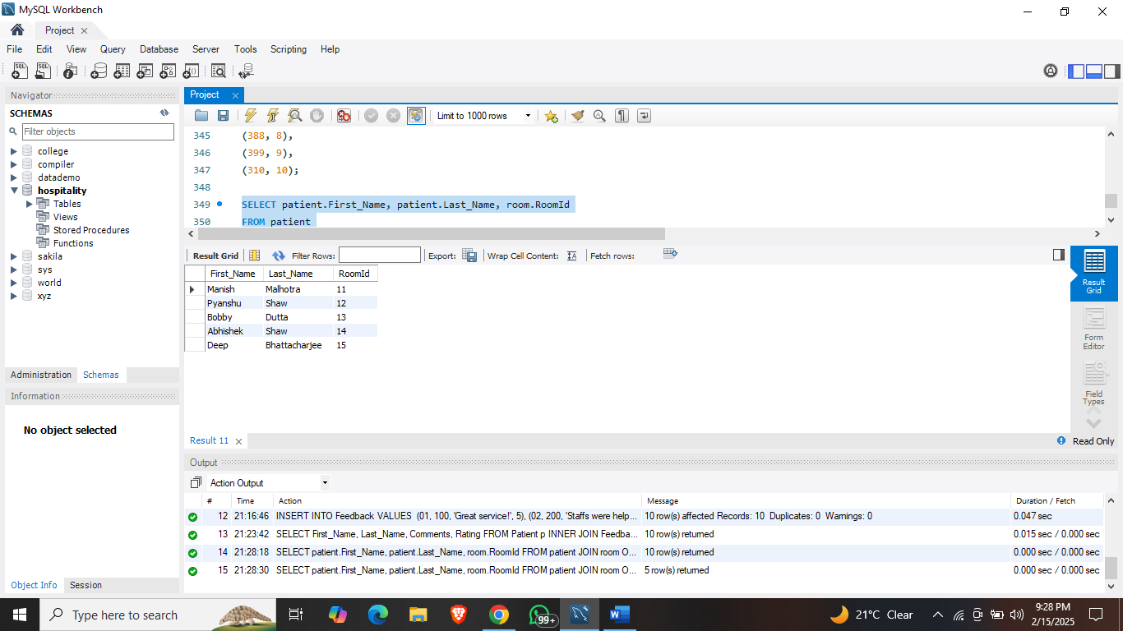JOIN room ON patient.RoomId = room.RoomId LIMIT 5;

**2: Find treatments along with their details and costs.**

SELECT Treatment_Name, Description, Price

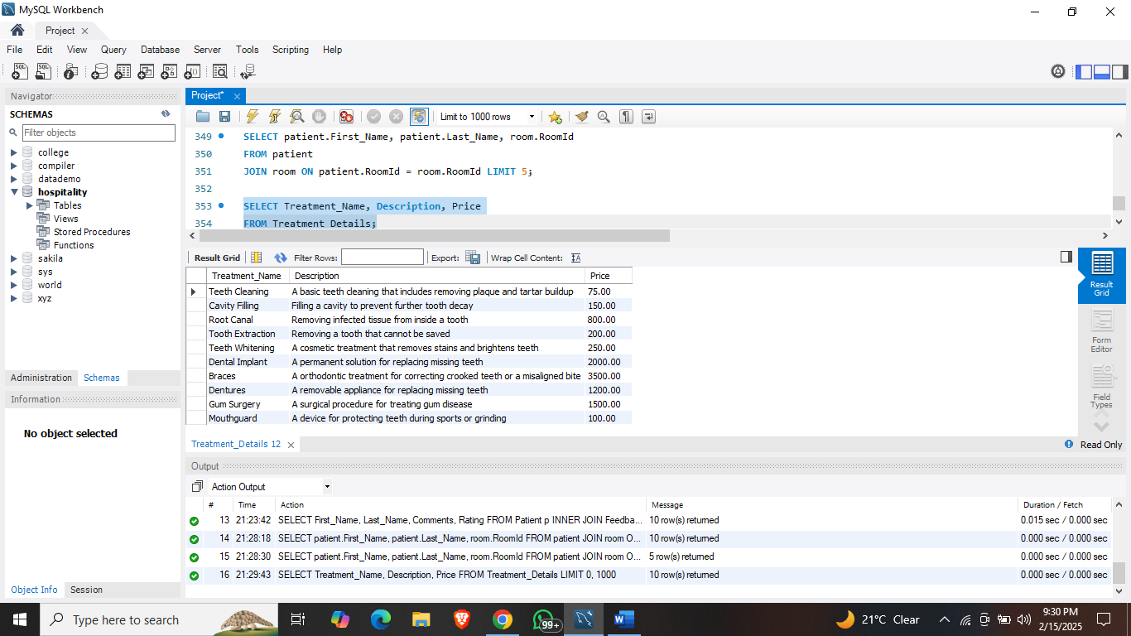FROM Treatment_Details;

**3: List all departments with their descriptions**

SELECT DeptName, Description FROM Dept;

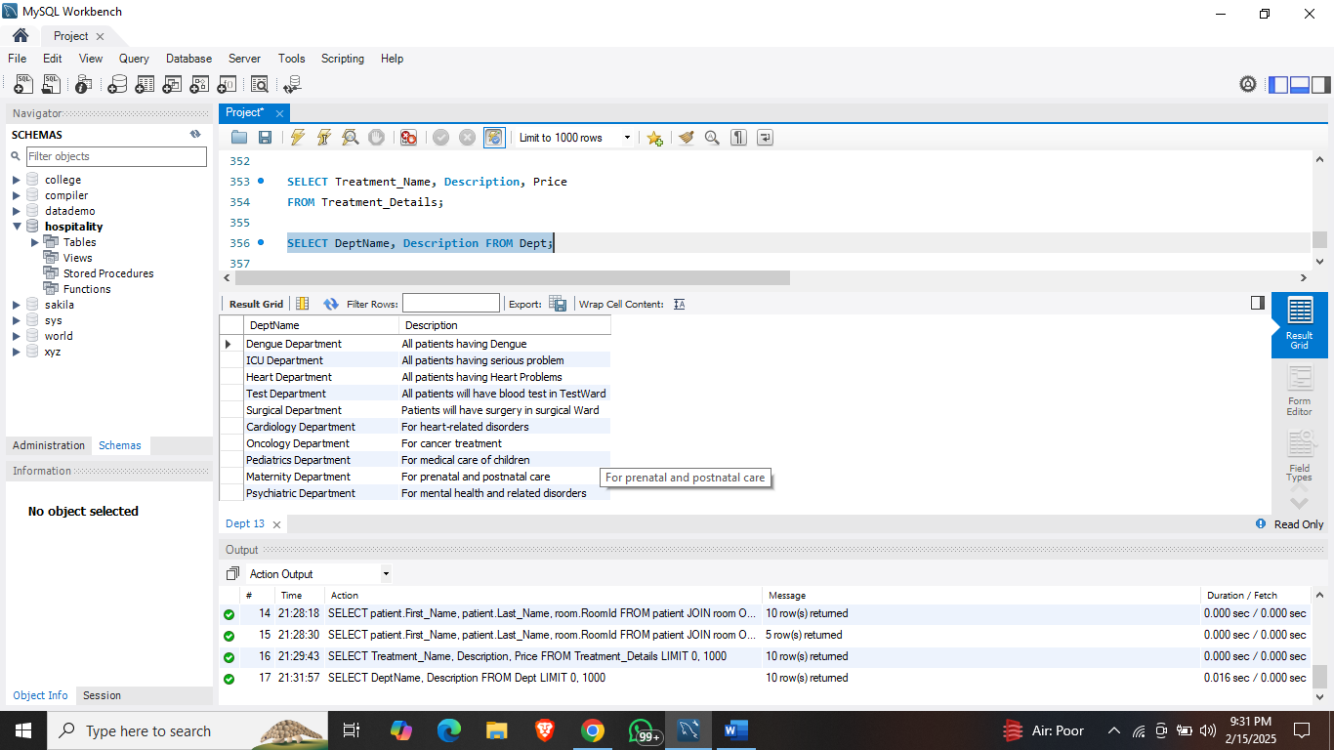

**4: Get all Prescription with their SideEffects.**

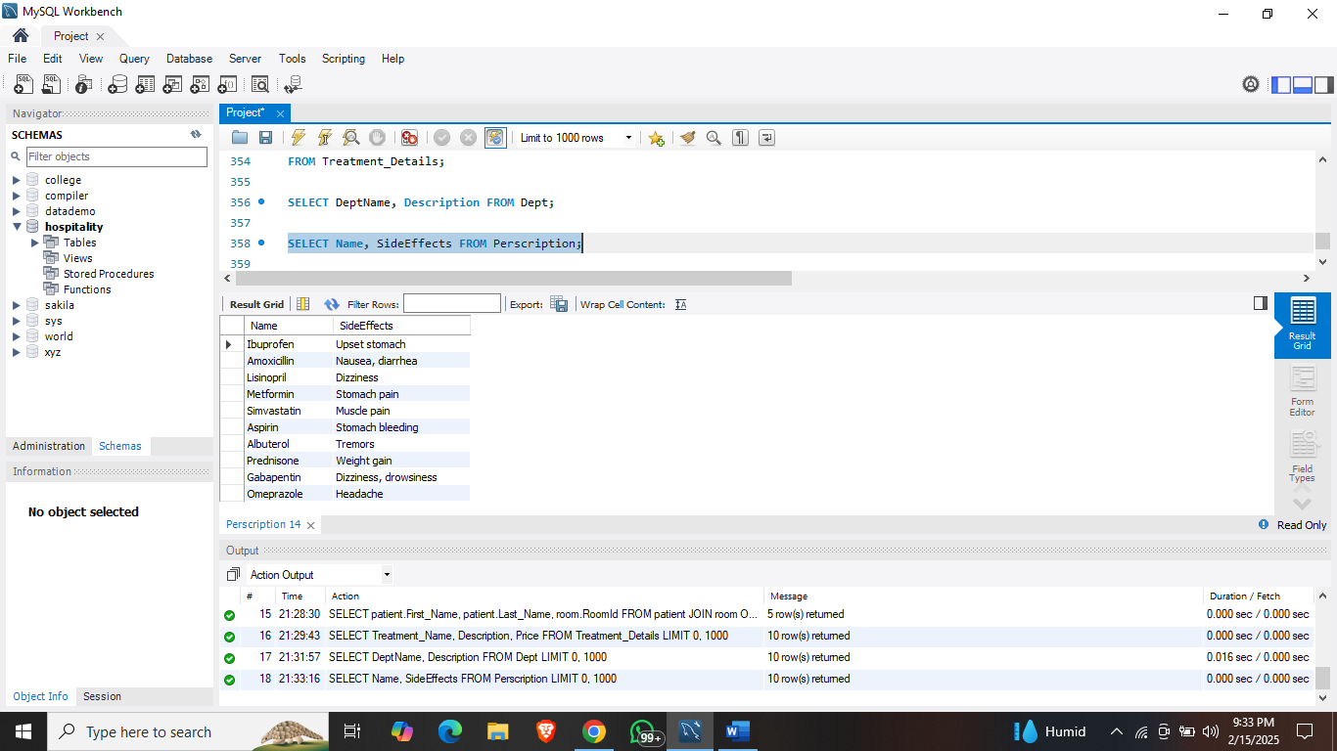SELECT Name, SideEffects FROM Perscription;

**5: Find patients with their respective current condition.**

SELECT First_name, Last_name , CurrentCondition

FROM Patient p

INNER JOIN Treatment t

ON p.PatientId = t.PatientId;

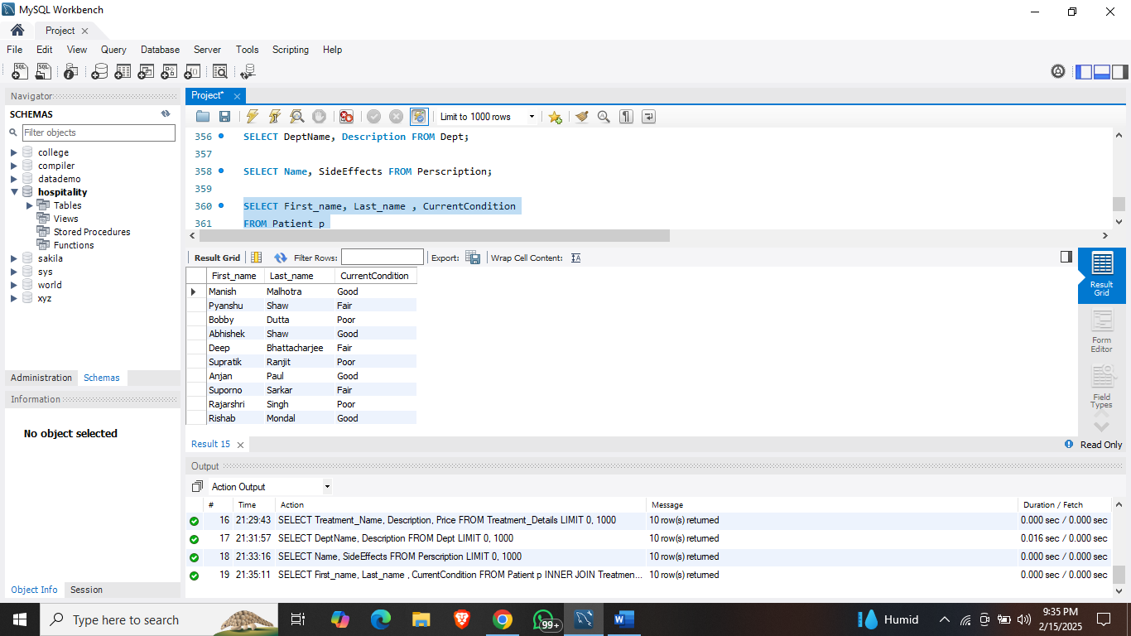

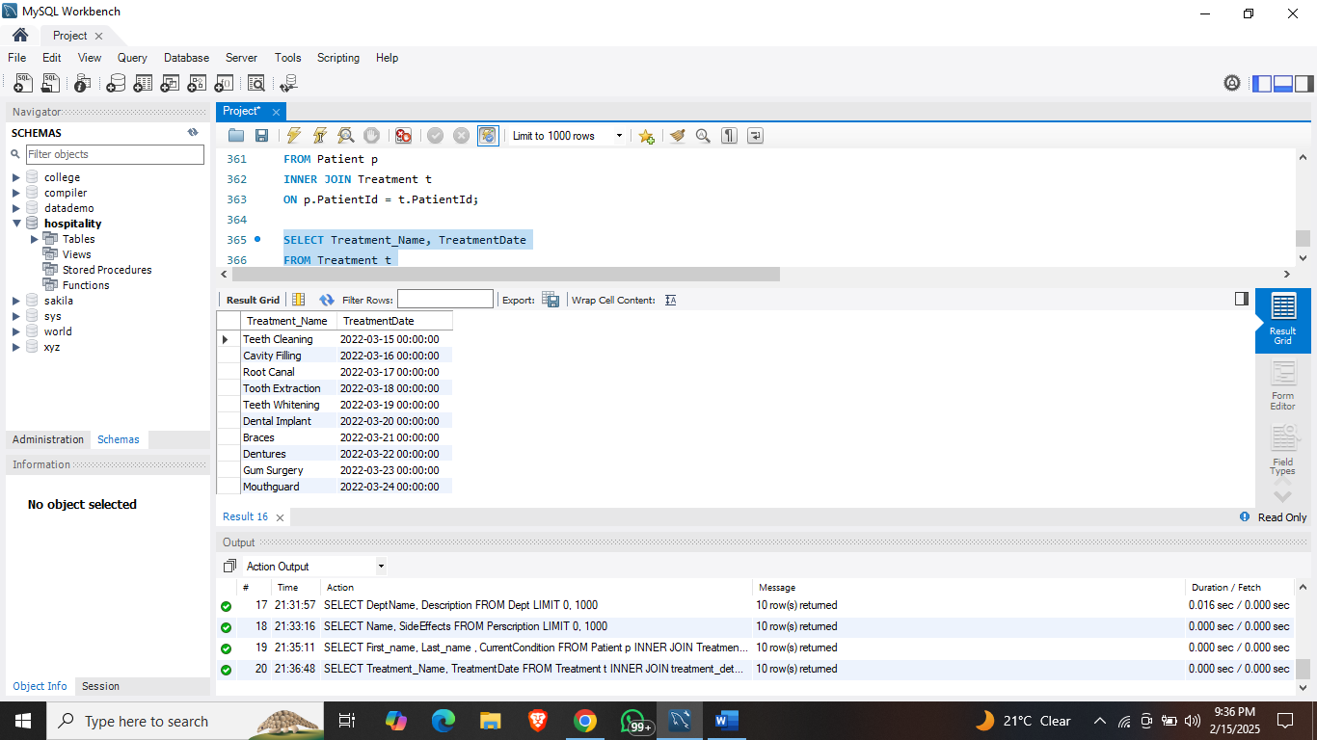

**6: List all treatment with their dates.**

SELECT Treatment_Name, TreatmentDate

FROM Treatment t

INNER JOIN treatment_details td

ON t.TreatmentDetailsId = td.Treatment_Id;

**6: List all patients with their total amount due.**

SELECT First_Name , Last_Name , TotalAmountDue

FROM Patient p

INNER JOIN Payment py

ON p.PatientId = py.PatientId;

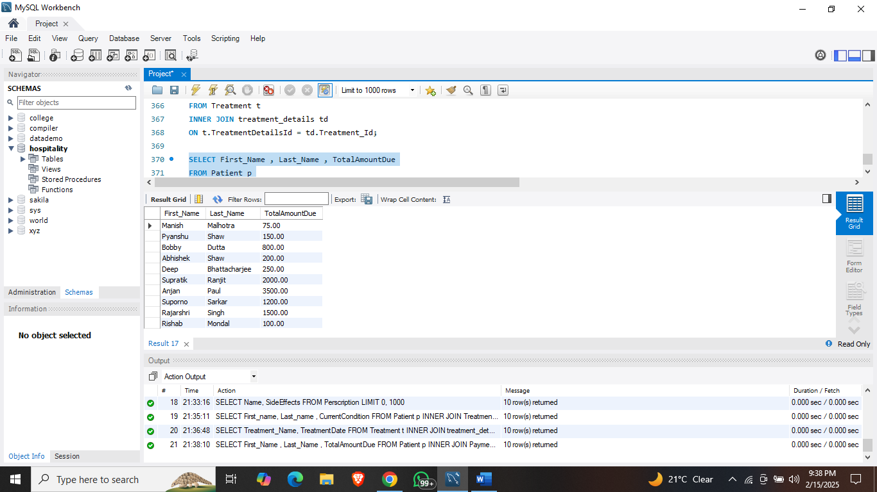

**7: List all patients with their Feedbacks.**

SELECT First_Name, Last_Name, Comments, Rating

FROM Patient p

INNER JOIN Feedback f

ON p.PatientId = f.CustomerID;

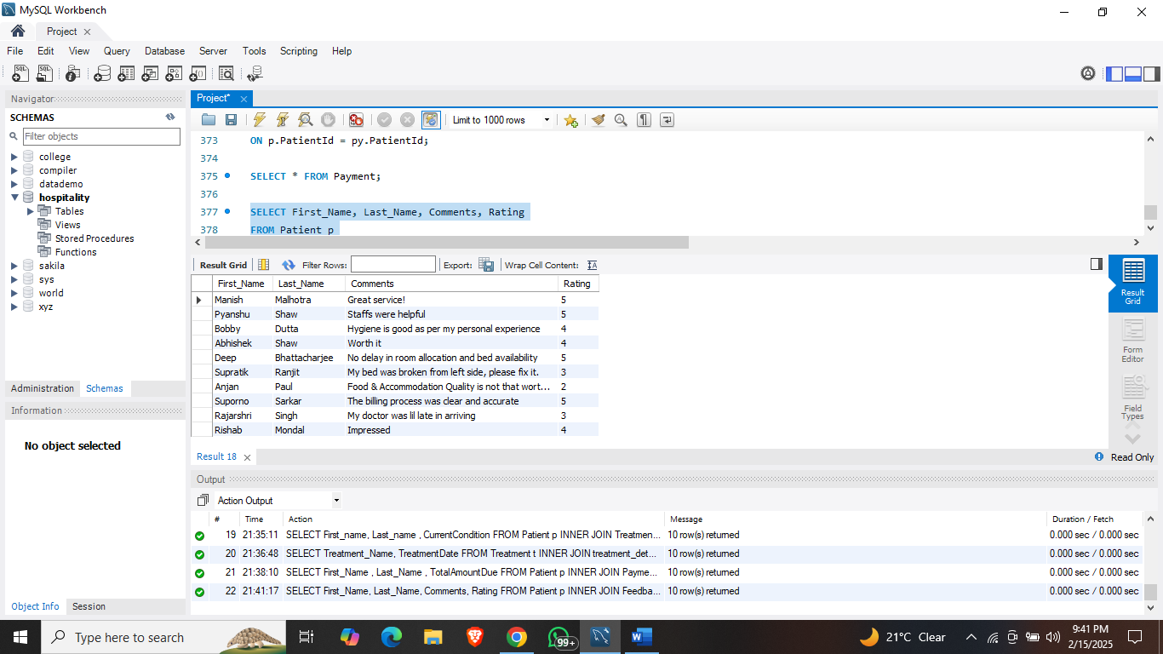

**8) Challenges Faced in the Project:**

* Ensuring data integrity through proper use of foreign keys and constraints.
* Handling concurrent bookings to avoid double reservations by adding unique constraints.
* Optimizing queries for faster execution, especially with large datasets.
* Designing a user-friendly schema that is scalable for future needs.

**9) Future Improvement Scope:**

* Integration with online booking platforms for real-time updates.
* Implementing advanced analytics for customer behavior and preferences.
* Adding role-based access control for different staff members.
* Incorporating automated notifications for bookings and payments.
* Including timestamp columns for better tracking and auditing of records.

**10) Conclusion:** This SQL-based Hospitality Management System addresses common challenges in managing hospital operations by automating data handling and ensuring data integrity. It enhances patients service, optimizes resource allocation, and provides a foundation for future scalability and technological integration.